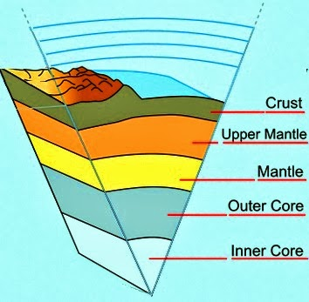 | Layer Name | Composition  (What materials fill the layer primarily and are there and sub layers?) | Thickness (in km) | State of Matter  (Solid or Liquid)  … or something else? | Density
Crust
Continental
Oceanic

 | Lithosphere | Layer that consists of the _________________ and the upper portion of the ___________________.
Mantle
Asthenosphere
Mesosphere
 | Outer Core
 | Inner Core
Convection in the Earth’s Layers
Mantle:  - Description:  - Effect on Earth: | Outer Core:  - Definition:  - Effect on Earth:

